**ASSIGNMENT-2**

**Cloud Project & Video Explainer**

IP ADDRESS- 51.20.11.128

DNS- <https://travel-madhav.online/>

[www.travel-madhav.online](http://www.travel-madhav.online)

NAME -MADHAV MAHARIA

STUDENT ID-35633154

Table of Contents

SETTING UP WEBSERVER- 3

WORDPRESS SETUP PROCESS 6

CHANGING THE SUB PATH 12

LINKING WITH DNS 13

SSL/TLS DOCUMENTATION 14

REFERENCE 16

Video explanation 16

# SETTING UP WEBSERVER-

1. GO TO THE EC2 DASHBOARD AND THEN CLICK ON LAUNCH INSTANCE-

1. CHOOSE UBUNTU AS OPERATING SYSTEM, CREATE A NEW KEY PAIR AND CLICK ON LAUNCH INSTANCE AND THEN ASSOCIATE ELASTIC IP ADDRESS

* NOW TO CONNECT INSTANCE WITH SSH I AM USING AN SSH CLIENT NAMED AS MOBA XTREM-

1. CLICK ON SSH AND TYPE UR STATIC IP ADDRESS IN REMOTE HOST AND THE SPEICFY USERNAME IS UBUNTU AND THEN GO THE ADVANCED SSH SETTINGS AND USE THE PRIVATE KEY TO LOG IN-

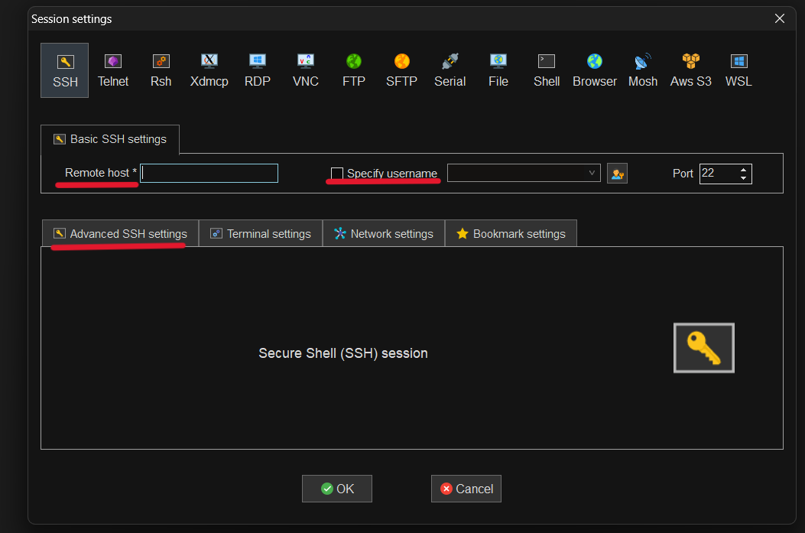

1. Install Apache server on Ubuntu



1. Install php runtime and php mysql connector



1. Install MySQL server



1. Login to MySQL server



1. Change authentication plugin to mysql_native_password



1. Create a new database user for wordpress



1. Create a database for wordpress



1. Grant all privilges on the database 'wp' to the newly created user



**FOR EXIT PRESS CTRL+X**

# WORDPRESS SETUP PROCESS

1. Download wordpress IN tmp directory

1. Unzip



1. Move wordpress folder to apache document root



1. Command to restart/reload apache server



1. Now type public address followed by /wordpress, then it will display a wordpress welcome page

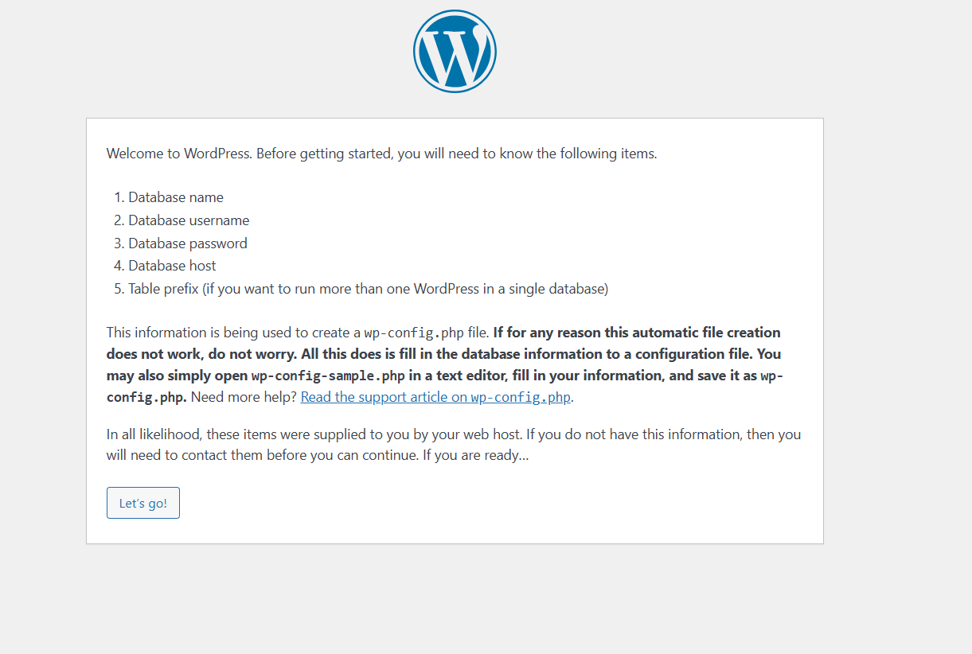

1. Then fill in the database details and click submit

1. Now after pressing the submission, it shows us UNABLE TO WRITE TO WP-CONFIG.PHP FILE
2. And below there is an instruction to create the wp-config.php file manually and paste the following text into it.

1. Now move directory and create and edit the file named as ‘wp-config.php’





1. Code that we pasted in wp-config.php

1. Fill in the information

1. login

# CHANGING THE SUB PATH

1. CHANGING APACHE CONFIGRATION





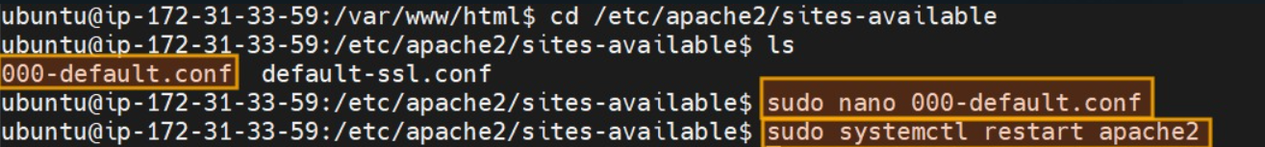

**RESTART APACH SERVER.**



# LINKING WITH DNS

1. CREATE HOSTED ZONE USING ROUTER53 AND THEN CREATE A RECORD OF A TYPE

COPY THE ROUTE TRAFFIC TO YOUR NAMERSERVER FOR DNS AND CHANGE NAMESERVER ON GODADDY( OR WHERE U HAVE BOUGHT THE DNS).

|  |
| --- |
| SSL/TLS DOCUMENTATION |

ENABLING HTTPS WITH CETRABOT ON UBUNTU 20.04 USING APACHE

1. INSTALLING CETRABOT

1. RUN CETRABOT WITH APACHE PLUGIN TO ATTAIN AND INSTALL SSL CERTIFICATE



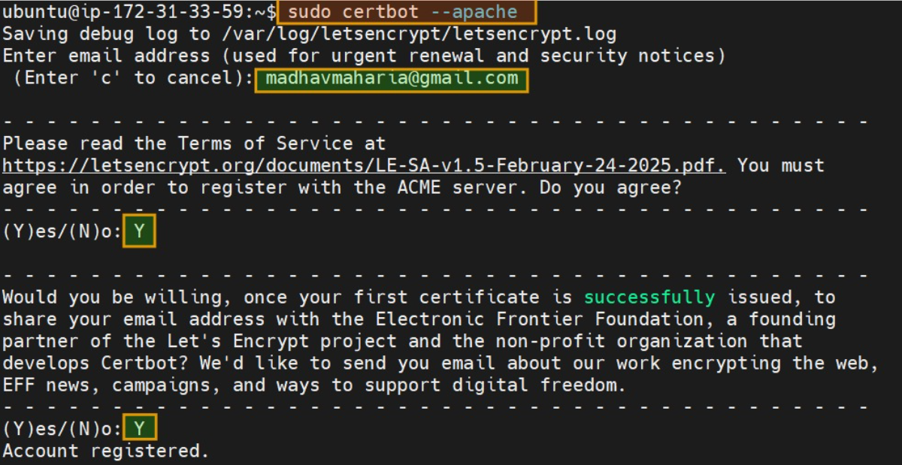

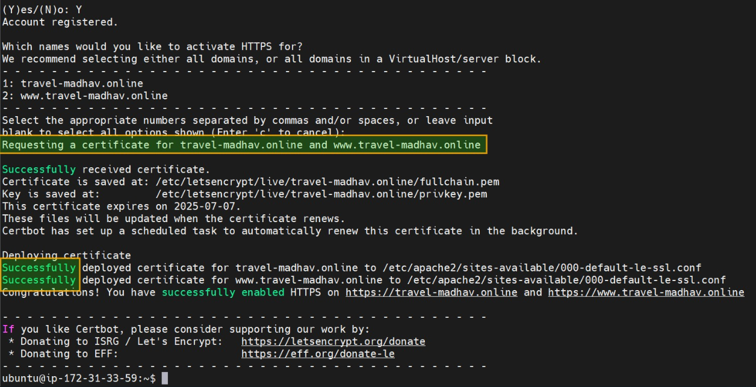

# REFERENCE

**The commands and steps used for deploying a WordPress website on an AWS EC2 instance were guided by Swaroop (2022), who provides a comprehensive Gist detailing the necessary configuration and deployment commands.**

**Swaroop, T. (2022, June 22). *Commands for deploying WordPress website on AWS EC2*. Gist.** [**https://gist.github.com/teja156/8c35a05f43635da4cbd06b47c0d91e93**](https://gist.github.com/teja156/8c35a05f43635da4cbd06b47c0d91e93)

# Video explanation

[**https://drive.google.com/file/d/1KJrdOuql_dhli_Sz-p-PAoBtwF2egheV/view?usp=drive_link**](https://drive.google.com/file/d/1KJrdOuql_dhli_Sz-p-PAoBtwF2egheV/view?usp=drive_link)